**RESTRICTED**

**RHS 68 galley-countertop - Install procedure**

**DMC:** BD700-A-J25-31-41-01AAC-720A-A

**Language:** sx/US

**Issue no:** 004

**Issue Date:** 2025-05-26

**Title:** RHS 68 galley-countertop - Install procedure

**Security classification:** Class02

**Responsible partner** Bombardier/3AB48

**company:**

|  |  |  |
| --- | --- | --- |
| **Originator:** | Bombardier/3AB48 | G25028029 REV C, G25043792 REV NC, |
| **Applicability:** | Model: BD700 |
| **Technical** | **Authority information:** |
| **standard:** | G25043794 REV NC |

**Authority exceptions:**

**Authority notes:**  G25023214 REV J

**Quality assurance** first verificationsecond verification Cleared Table Top

**status:**

|  |  |
| --- | --- |
| **Reason for updating:** | This DM is updated to reflect engineering available at the time of authoring. |

See applicability on the   
first page of the DM

**BD700-A-J25-31-41-01AAC-720A-A**

BD700-A-J25-31-41-01AAC-720A-A   
 **RESTRICTED 2025-05-26 Page 1**

**RESTRICTED**

Intentionally left blank

See applicability on the   
first page of the DM

**BD700-A-J25-31-41-01AAC-720A-A**

BD700-A-J25-31-41-01AAC-720A-A   
 **RESTRICTED 2025-05-26 Page 2**

**RESTRICTED**

**RHS 68 galley-countertop - Install procedure**

Applicability: Model: BD700

**Table of contents**  Page

RHS 68 galley-countertop - Install procedure..................................................................... 1

References................................................................................................................................ 1

Preliminary requirements......................................................................................................... 2

Procedure.................................................................................................................................. 3

Requirements after job completion........................................................................................ 6

**List of tables**  Page

1 References.................................................................................................................. 1

2 Required conditions................................................................................................... 2

3 Support equipment.................................................................................................... 2

4 Consumables, materials, and expendables............................................................ 2

5 Spares......................................................................................................................... 2

6 Required conditions................................................................................................... 6

**List of figures**  Page

1 RHS 68 galley-countertop........................................................................................ 4

***References***

*Table 1 References*

|  |  |
| --- | --- |
| Data Module/Technical Publication | Title |

BD700-A-J25-31-41-01AAC-520A-A BD700-A-J20-50-00-00AAA-711A-A BD700-A-J33-51-03-01AAA-720A-A

BD700-A-J51-24-00-00AAA-690A-A

BD700-A-J51-24-00-03AAA-621A-A

RHS 68 galley-countertop - Remove procedure Threaded fasteners - Tighten procedure   
Entrance-area emergency-lighting exit-sign - Install procedure   
Preparation of surfaces for adhesive-bonding and painting - Miscellaneous   
Bonding with Silicone adhesive - Bond

See applicability on the first page of the DM

**BD700-A-J25-31-41-01AAC-720A-A**

BD700-A-J25-31-41-01AAC-720A-A   
**RESTRICTED 2025-05-26 Page 1**

**RESTRICTED**

***Preliminary requirements***

**Required conditions**

*Table 2 Required conditions*

|  |  |
| --- | --- |
| Action/Condition | Data Module/Technical publication |
| Make sure the aircraft is in the same | BD700-A-J25-31-41-01AAC-520A-A |

configuration as the remove data module.

**Support equipment**

*Table 3 Support equipment*

|  |  |  |  |
| --- | --- | --- | --- |
| Name | Identification/Reference | Quantity | Remark |
| Torque wrench | std-0020 | 1 |  |

**Consumables, materials, and expendables**

*Table 4 Consumables, materials, and expendables*

|  |  |  |  |
| --- | --- | --- | --- |
| Name | Identification/Reference | Quantity | Remark |
| Silicone adhesive (RTV | 06-065 | As |  |
| 108 TY 4) | 07-001 | necessary |
| Isopropyl alcohol | As |

necessary

|  |  |  |
| --- | --- | --- |
| Lint-free cloth | 05-001 | As |

necessary

**Spares**

*Table 5 Spares*

|  |  |  |  |
| --- | --- | --- | --- |
| Name | Identification/Reference | Quantity | Remark |
| galley countertop | CSN 25-31-41- | 1 |  |

01AAE001

**Safety conditions**

None

See applicability on the first page of the DM

**BD700-A-J25-31-41-01AAC-720A-A**

BD700-A-J25-31-41-01AAC-720A-A   
 **RESTRICTED**  **2025-05-26 Page 2**

**RESTRICTED**

***Procedure***

1 For an illustration with this procedure, refer to Fig. 1.

2 To install the galley countertop (CSN 25-31-41-01AAE001) (3), do the steps that

follow:

2.1 Clean the faying surface with lint-free cloth (05-001) made moist with

isopropyl alcohol (07-001). Refer to BD700-A-J51-24-00-00AAA-690A-A.

2.2 Put the galley countertop (CSN 25-31-41-01AAE001) (3) in position.

2.3 Bond the internal edges of the galley

countertop (CSN 25-31-41-01AAE001) (3) on the galley with silicone

adhesive (06-065). Refer to BD700-A-J51-24-00-03AAA-621A-A.

**Note**

The silicone adhesive should flush with the galley

countertop (CSN 25-31-41-01AAE001) (3) for the horizontal gaps and

with the panels for the vertical gaps.

2.4 Install the washers (5) and screws (4).

2.5 With a torque wrench (Commercially available, Pt. No. std-0020),

tighten the screws (4) from 13 to 16 lbf·in (1,47 to 1,80 Nm). Refer to

BD700-A-J20-50-00-00AAA-711A-A.

2.6 Install the sink cover (2).

3 To install the cap assembly (11), do the steps that follow:

3.1 Put the cap assembly (11) in position.

3.2 Install the bolts (9) and the pin (10).

3.3 With a torque wrench (Commercially available, Pt. No. std-0020),

tighten the bolts (9) from 13 to 16 lbf·in (1,47 to 1,80 Nm). Refer to

BD700-A-J20-50-00-00AAA-711A-A.

3.4 Install the washers (8) and the screws (7).

3.5 With a torque wrench (Commercially available, Pt. No. std-0020),

tighten the screws (7) from 13 to 16 lbf·in (1,47 to 1,80 Nm). Refer to

BD700-A-J20-50-00-00AAA-711A-A.

|  |  |  |
| --- | --- | --- |
| 4  5 | 3.6 | If removed, install the deco panel (6). |
| Install the applicable drawers (1).  Close the nesting door. | |

See applicability on the first page of the DM

**BD700-A-J25-31-41-01AAC-720A-A**

BD700-A-J25-31-41-01AAC-720A-A   
**RESTRICTED 2025-05-26 Page 3**

**RESTRICTED**

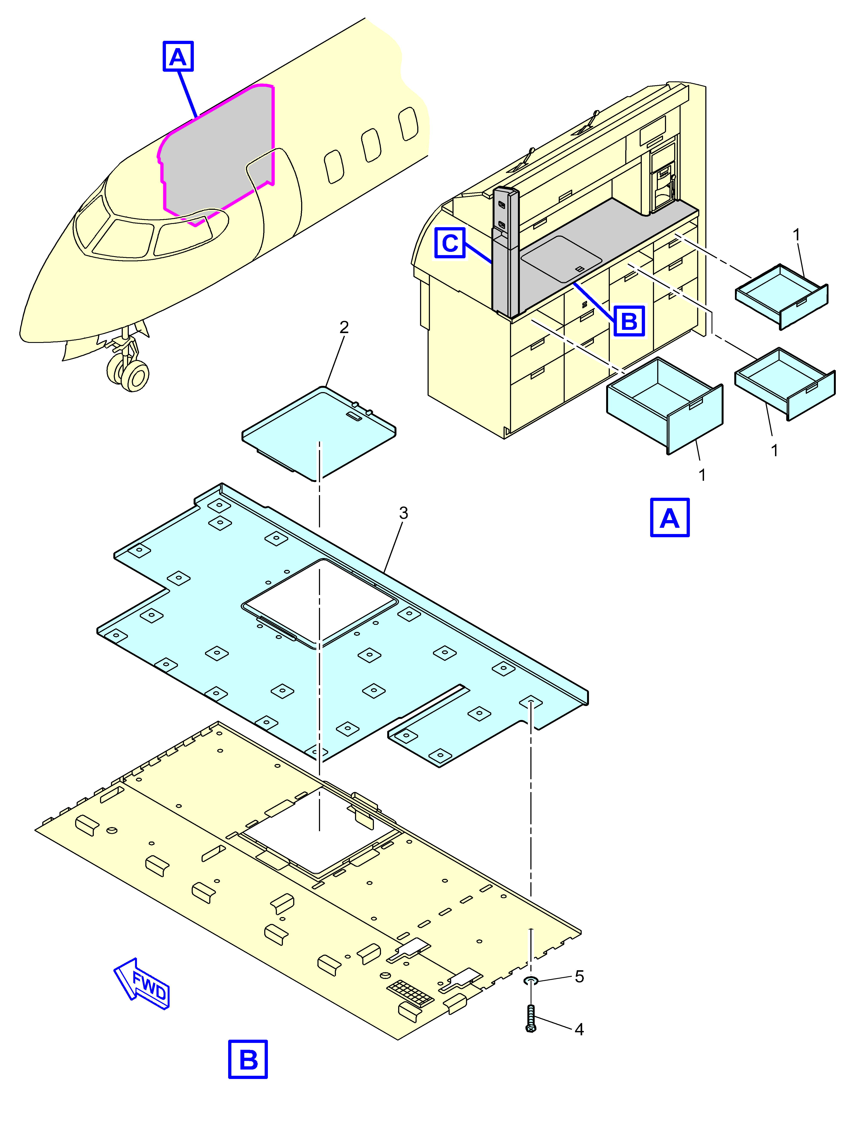

ICN-BD700-A-J253141-H-3AB48-51699-A-001-01

*Figure 1 RHS 68 galley-countertop - (Sheet 1 of 2)*

See applicability on the first page of the DM

**BD700-A-J25-31-41-01AAC-720A-A**

BD700-A-J25-31-41-01AAC-720A-A   
 **RESTRICTED**  **2025-05-26 Page 4**

**RESTRICTED**

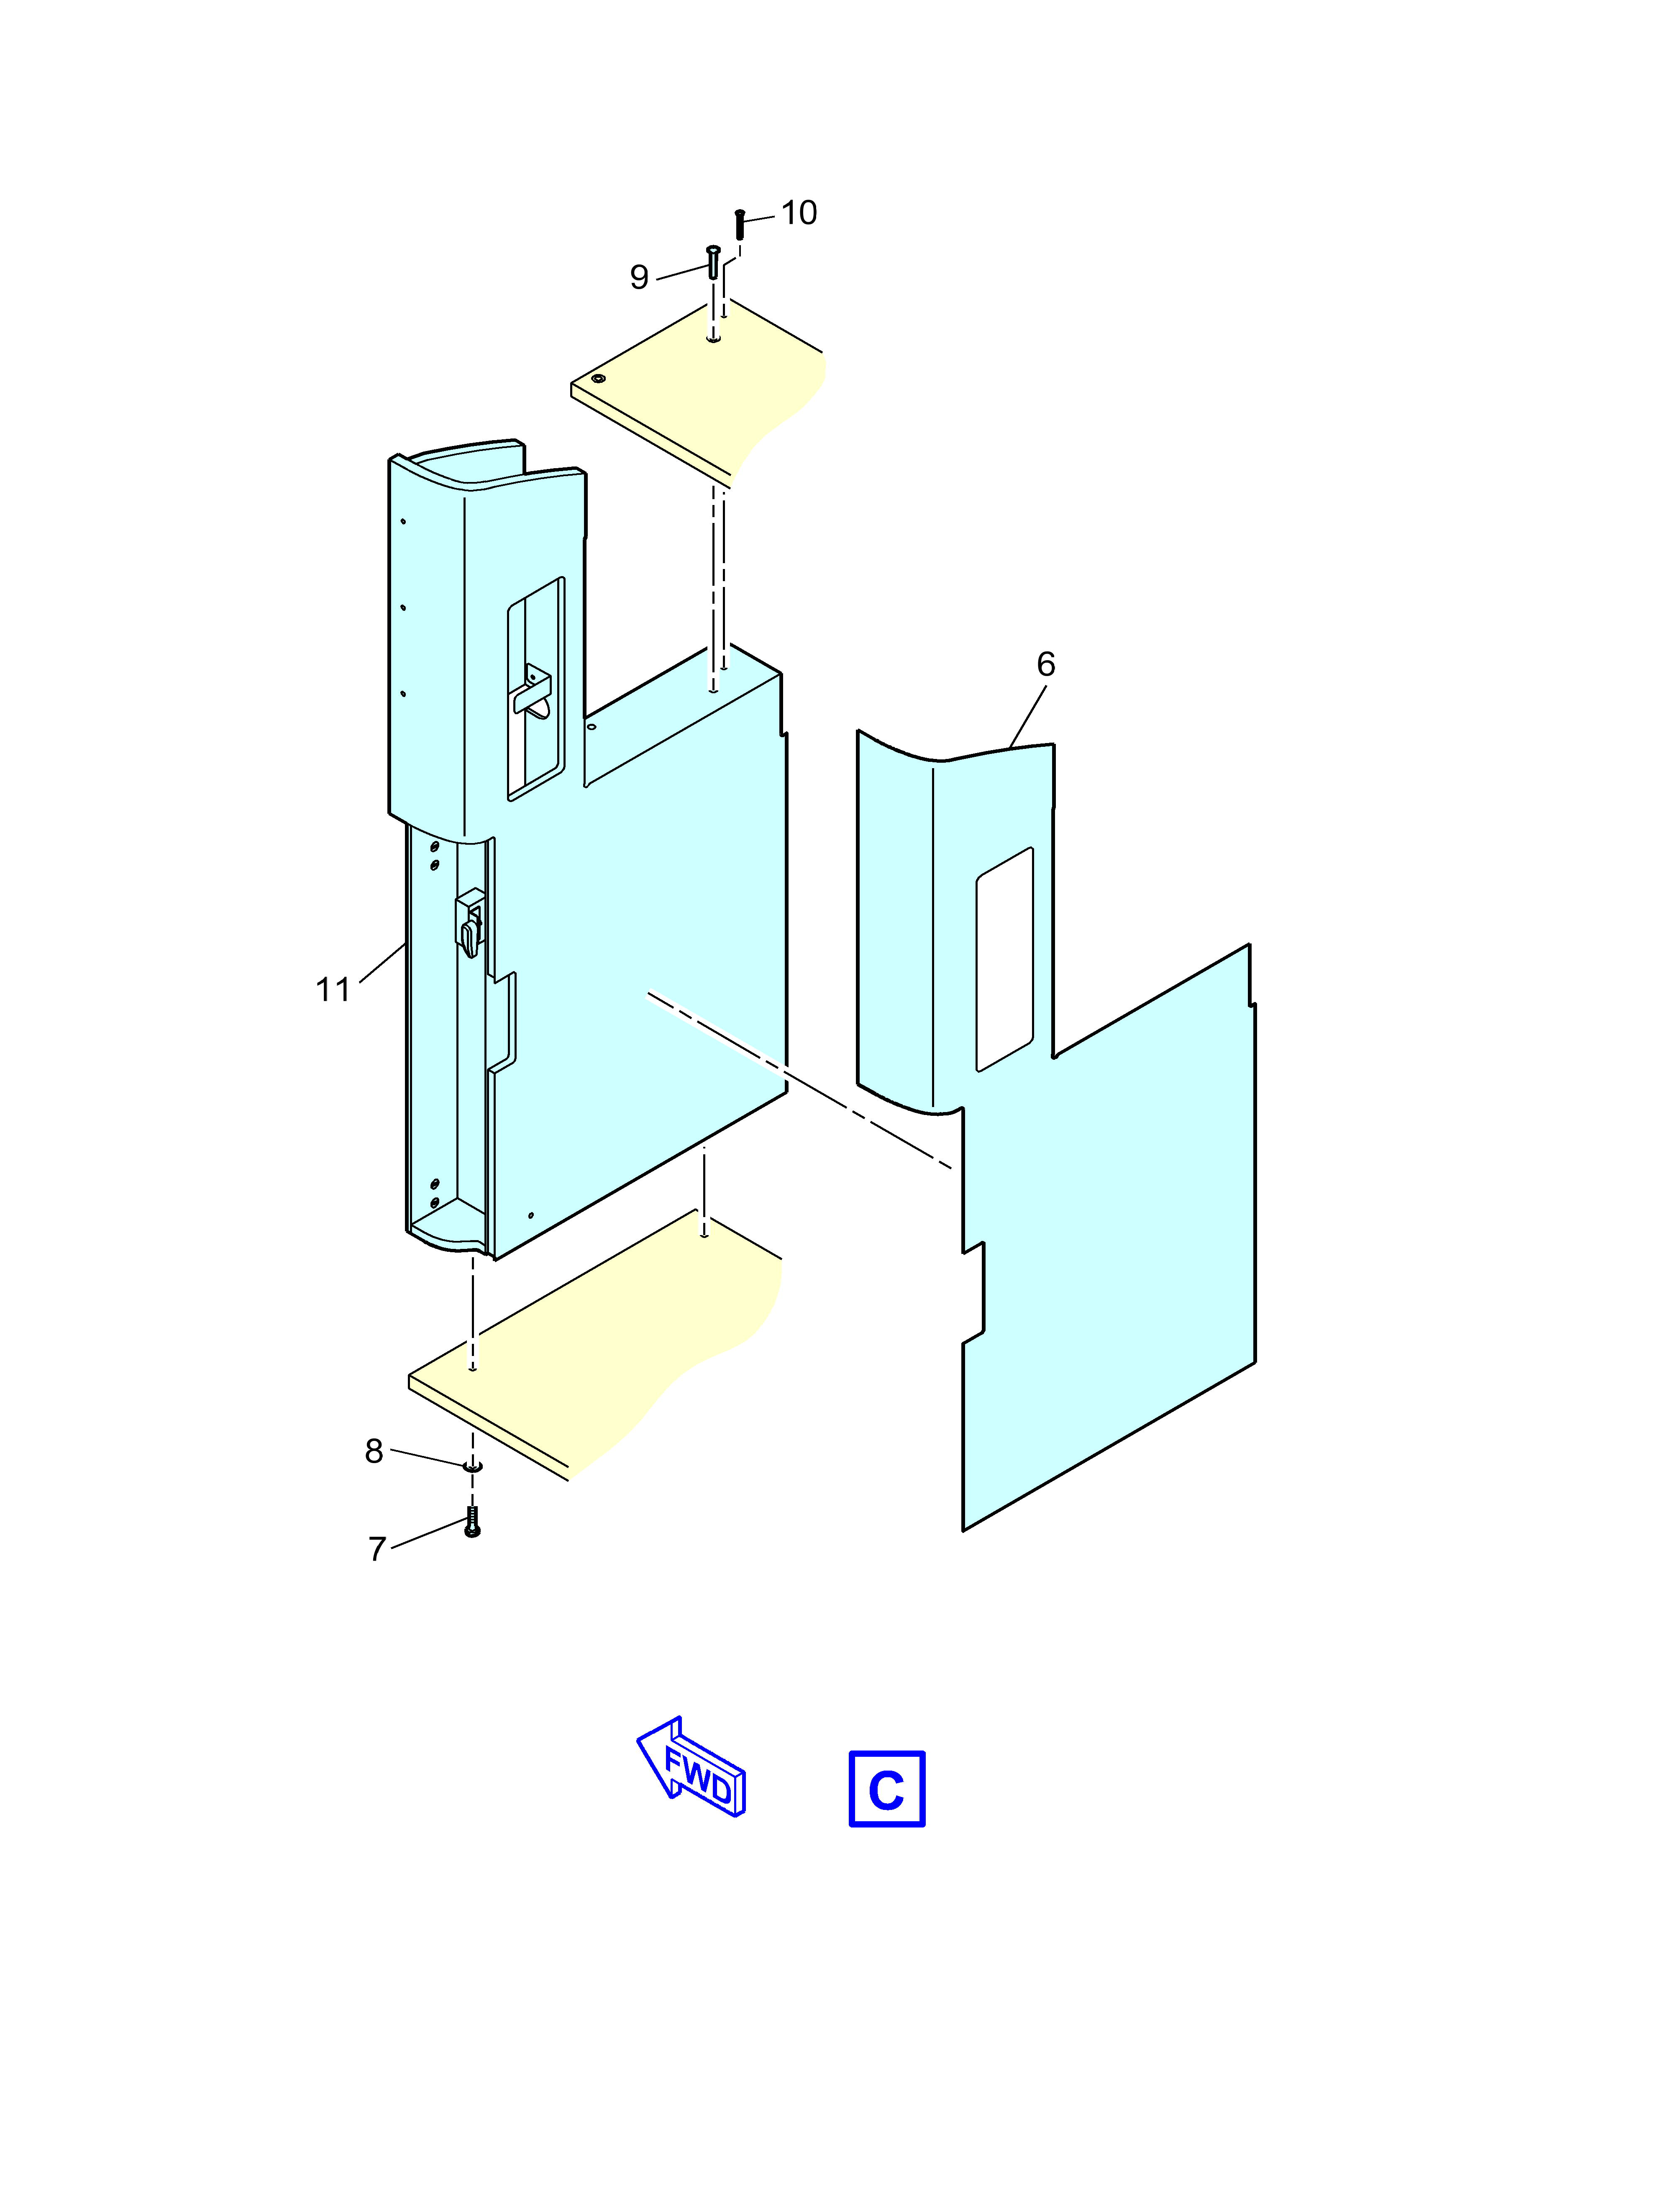

ICN-BD700-A-J253141-H-3AB48-51695-A-001-01

*Figure 1 RHS 68 galley-countertop - (Sheet 2 of 2)*

See applicability on the first page of the DM

**BD700-A-J25-31-41-01AAC-720A-A**

BD700-A-J25-31-41-01AAC-720A-A   
**RESTRICTED 2025-05-26 Page 5**

**RESTRICTED**

***Requirements after job completion***

**Required conditions**

*Table 6 Required conditions*

|  |  |
| --- | --- |
| Action/Condition | Data Module/Technical publication |

Remove all the tools, equipment, and   
unwanted materials from the work area.

Do the procedure to install the galley   
sink (25-33-21-01).

Do the procedure to install the kettle (25-  
33-09-01).

Do the procedure to install the   
temperature sensor (21-61-01-06).

Do the procedure to install the wine   
drawer (25-31-27-01).

Do the procedure to install the warming   
drawer (25-33-17-01).

Do the procedure to install the entrance-area emergency-lighting exit-sign.

BD700-A-J33-51-03-01AAA-720A-A

See applicability on the   
first page of the DM   
BD700-A-J25-31-41-01AAC-720A-A

**End of data module**   
 **RESTRICTED**  **2025-05-26 Page 6**